Jump Host (Bastion Host), NAT Gateway, and NAT Instance - Detailed Documentation
Jump Host / Bastion Host

What is a Jump Host (Bastion Host)?
A Jump Host (also called a Bastion Host) is a secure server placed in a public subnet that allows administrators to access private servers inside a private subnet.
It acts as an entry point to access internal resources securely.
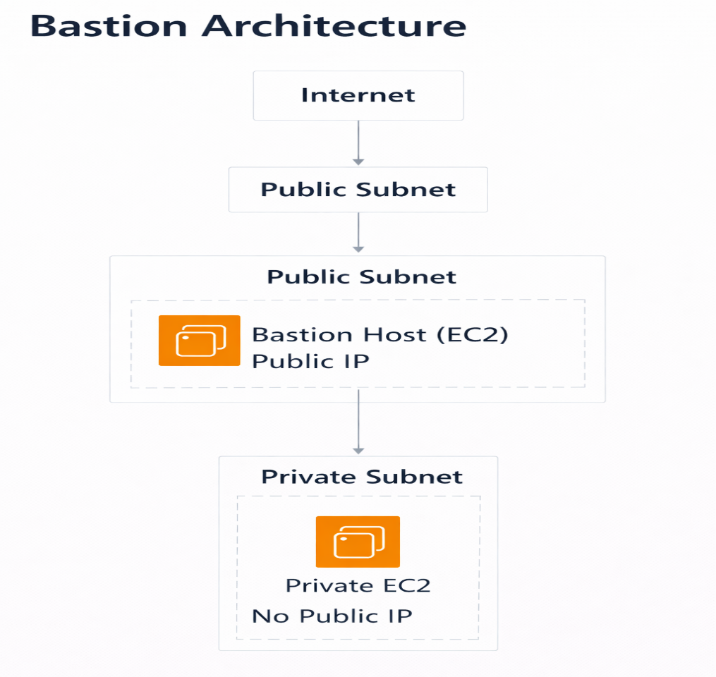

Why Bastion Host is Used
Private subnet instances:
- Do not have public IP
- Cannot be accessed directly from the internet
- Are protected for security
So we use:
Internet → Bastion Host → Private Server

How Bastion Host Works
Step-by-step:
- User connects to Bastion Host using SSH
- Bastion Host connects to Private Server
- Private servers remain hidden from internet

Bastion Host Security Rules

Bastion Security Group
Allow:
Type: SSH
Port: 22
Source: Your IP address

Private Instance Security Group
Allow SSH only from Bastion Host:
Type: SSH
Port: 22
Source: Bastion Security Group

Bastion Host Use Cases
- Secure SSH access to private servers
- Database administration
- Production environment access
- Remote infrastructure management

Real-Time Example
Company setup:
Web Server → Public Subnet
App Server → Private Subnet
DB Server → Private Subnet
Admin Access → Bastion Host
Admin Flow:
Laptop → Bastion → App Server → Database

When We Use Bastion Host
We use Bastion Host when:

1.Access Private Servers Securely
Private servers do not have public IP.
Example:
- App server in private subnet
- Database server in private subnet
Access flow:
Admin → Bastion → Private EC2

NAT Gateway

What is NAT Gateway?
A NAT Gateway allows private subnet instances to access the internet without exposing them to incoming internet traffic.
Private instances:
Can access internet
Cannot be accessed from internet

Why NAT Gateway is Needed
Private servers need internet access for:
- Software updates
- Download packages
- OS patches
- External API calls
Without NAT:
apt update ❌ fails
yum install ❌ fails
wget ❌ fails

NAT Gateway Architecture
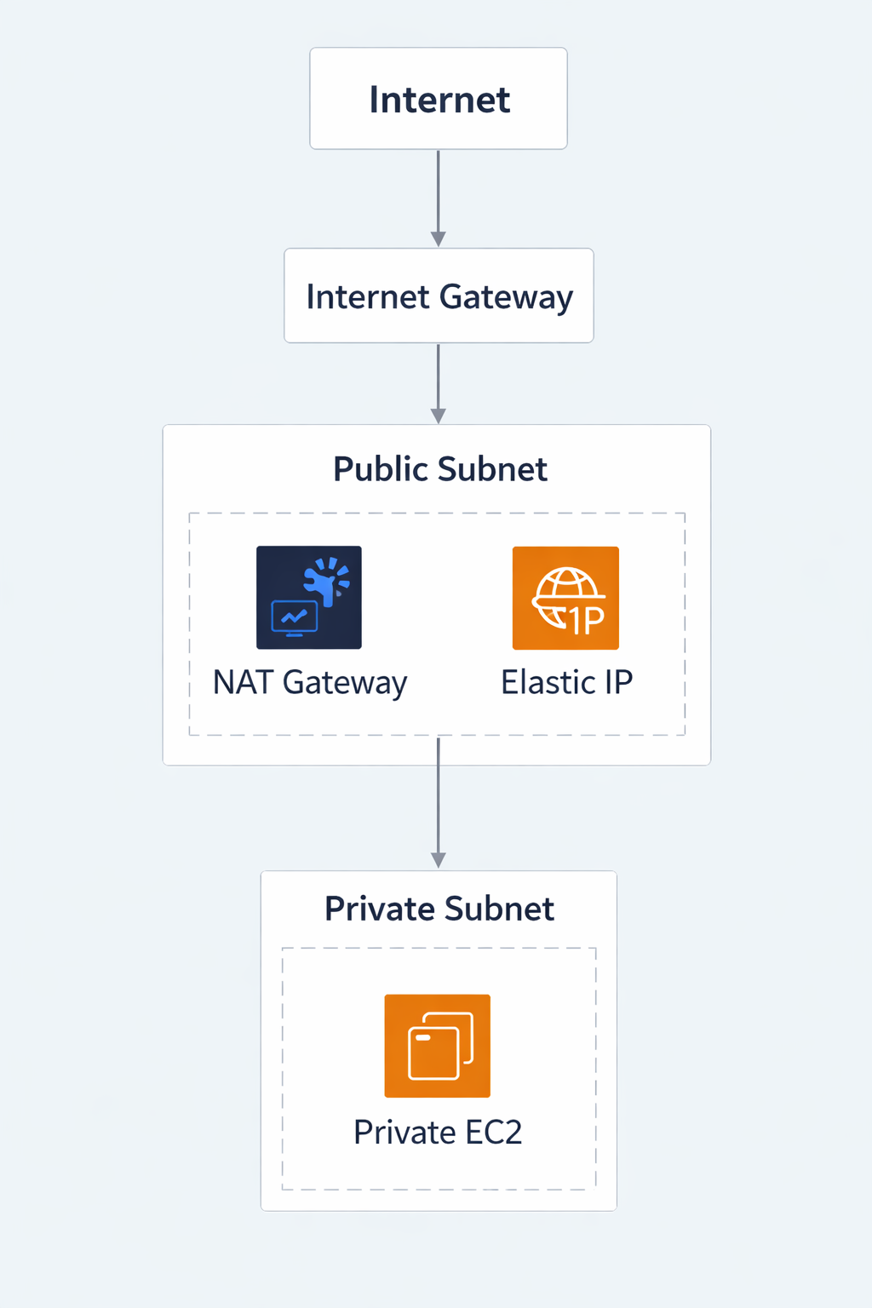

NAT Gateway Requirements
Must have:
✔ Public Subnet
✔ Internet Gateway
✔ Elastic IP

NAT Gateway Route Table Setup

Public Route Table
Destination: 0.0.0.0/0
Target: Internet Gateway

Private Route Table
Destination: 0.0.0.0/0
Target: NAT Gateway

NAT Gateway Advantages
- Fully managed by AWS
- Highly available
- Scalable automatically
- No maintenance required

NAT Gateway Disadvantages
- Costs money per hour
- Additional data transfer cost
When We Use NAT Gateway
We use NAT Gateway when:

1.Private Servers Need Internet Access
Private EC2 needs:
- Software updates
- Security patches
- Download dependencies

2. Secure Internet Access for Private Systems
We want:
✔ Outgoing access
❌ Incoming access

3.Production Environments (Most Common Use)
NAT Gateway is widely used in:
- Enterprise applications
- SaaS platforms
- Web applications
Typical production design:
Public Subnet:
Load Balancer
NAT Gateway
Private Subnet:
App Servers
DB Servers

When High Availability Is Required
NAT Gateway:
✔ Managed by AWS
✔ Highly reliable
✔ Automatically scalable

NAT Instance

What is NAT Instance?
A NAT Instance is an EC2 instance configured to act as a NAT device.
It performs the same function as NAT Gateway but is self-managed.
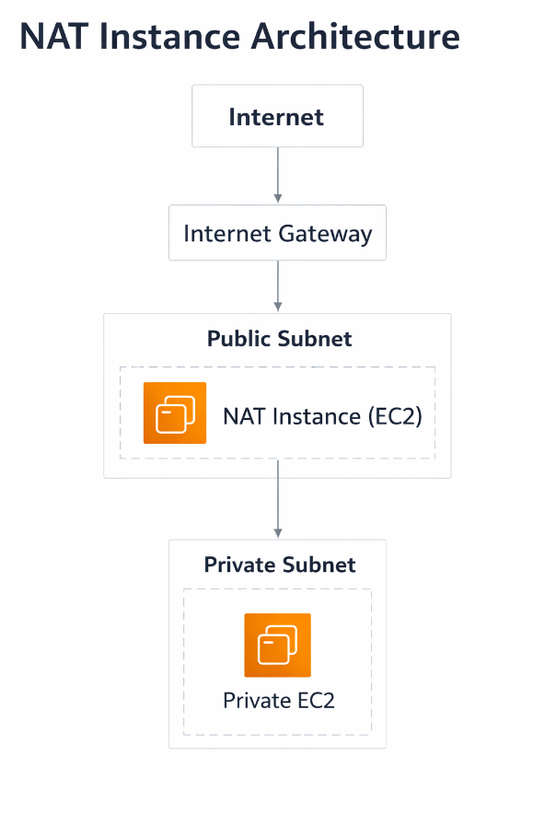

NAT Instance Requirements
Must configure:
✔ Disable Source/Destination Check
✔ Enable IP Forwarding
✔ Configure iptables
✔ Assign Elastic IP

NAT Instance Advantages
- Cheaper than NAT Gateway
- Fully customizable
- Useful for small environments

NAT Instance Disadvantages
- Requires maintenance
- Manual scaling
- Single point of failure

Less reliable than NAT Gateway
When We Use NAT Instance
We use NAT Instance when:
- Low-Cost Environments
NAT Gateway costs money hourly.
For:
- Labs
- Testing
- Small projects
NAT Instance is cheaper.

2. Custom Network Configurations
Sometimes we need:
- Custom routing rules
- Firewall rules
- Traffic inspection
NAT Instance allows customization.

3. Learning and Testing
Used in:
- DevOps labs
- AWS practice environments
- Small workloads

4. Small Traffic Workloads
If traffic is low:
- NAT Instance is sufficient
- Cost savings possible
NAT Gateway vs NAT Instance
Feature | NAT Gateway | NAT Instance
Managed by AWS | Yes | No
High Availability | Yes | No
Maintenance | None | Required
Performance | High | Medium
Cost | Higher | Lower
Scaling | Automatic | Manual

Bastion Host vs NAT Gateway
Feature | Bastion Host | NAT Gateway
Purpose | SSH access | Internet access
Used by | Admin users | Private servers
Internet access | Yes | Yes
Direct login | Yes | No

